The Sensory System – Chapter 9
9.3 SENSE OF VISION
Location of the Eye
1) Located in orbits made of seven bones: frontal, lacrimal, ethmoid, zygomatic, maxilla, sphenoid, and palatine.
2) Supraorbital ridge- bony ridge superior to the orbits responsible to protect eye from blows.

Accessory Organs of the Eye

Eyebrows, Eyelids, and Eyelashes
1) Eyebrows- transverse thick hairs that shade eyes from sun and prevent debris from getting in eye.
2) Eyelids and eyelashes serve to protect the eye.
a) Orbicularis oculi- muscle closes the lid
b) Levator palpebrae superioris- raises the lid
c) Sty- inflammation of a sebaceous gland of the eyelash
3) Blinking- keeps the eye lubricated and protected
4) Conjunctiva- transparent mucous membrane on inner surface of eyelid that curves and covers the anterior portion of the eye (except cornea)

Lacrimal Apparatus
1) Lacrimal gland- lies in lateral orbit above the eye produces tears that flow over the eye when it blinks
2) Lacrimal sac- two ducts at inner eye collect tears into sac and then into nose.
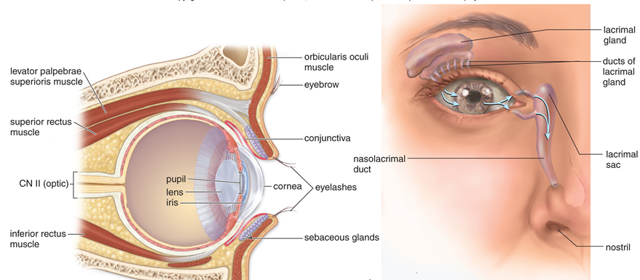
Extrinsic Muscles
1)Three pairs of antagonistic muscle responsible for movement of the eye.
a) Superior rectus (upward): inferior rectus (downward)
b) Lateral rectus (outward): medial rectus (inward)
c) Superior oblique (rotates counterclockwise): inferior oblique (eye clockwise)
2) Cranial nerves
a) Optic (II) – retina for sense of sight
b) Oculomotor (III)- Eye muscle and lens
c) Trochlear (IV)- Eye muscles
d) Abducens (VI)- Eye muscles
Anatomy and Physiology of the Eye

1) Sclera- tough outermost connective tissue layer; protects and supports the eye
a) Cornea- transparent tissue that refracts (bends) light rays
2) Choroid- layer that contains blood vessels and absorbs stray light
a) Iris- smooth muscle that regulates entrance of light into retina
b) Pupil- opening in iris; admits light into the retina
c) Ciliary body- holds the lens in places
d) Ciliary muscle- accommodation; changes the shape of the lens for near & far vision
3) Retina- layer that contains sensory receptors for light
a) Rods- receptors for black and white, dim light vision, peripheral vision
b) Cones- receptors for color vision; bright light vision
c) Fovea centralis- largest concentration of cone cells; makes acute vision possible
d) Optic nerve- transmits visual signals to the brain
4) Lens- refracts (bends) and focuses light rays
a) Suspensory ligaments- support lens; attach lens to ciliary body
5) Aqueous humor- clear watery fluid of anterior compartment; transmits light rays
6) Vitreous humor- clear, gelatinous material of posterior compartment; transmits light rays

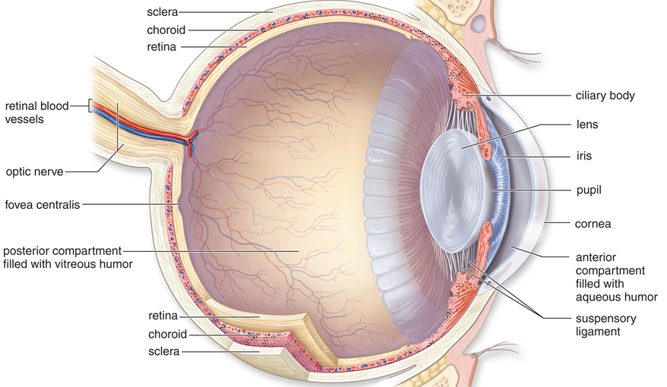

Function of the lens
1) Lens along with cornea, humors focus image on retina
2) Images are much smaller and inverted as projected onto the retinal

Accommodation
1) Changing of the lens shape in order to maintain focus on near and far objects.
2) Distant object- ciliary muscle relaxes, suspensory ligament taunt and lens is flat
3) Near object- ciliary muscle contracts, suspensory ligament relaxed and lens rounds out
a) Eyestrain- caused by continuous contraction of ciliary muscles
b) After age 40, lens loses elasticity
Vision Pathway

Function of Photoreceptors
1) Have an outer segment joined to an inner segment by a stalk.
2) Pigment cells found in the membrane disks
3) Synaptic vesicles are located at the synaptic endings

Rods
1) Rhodopsin- deep purple pigment that becomes opsin and retinal when a rod absorb lights
2) Light stimulus stops the release of neurotransmitters- results in action potentials
3) Nerve signals travel to the visual cortex
4) Rods are plentiful in retina, none in the fovea centralis
5) Allows us to have peripheral vision, night vision, and perception of motion.

Cones
1) Located mainly in the fovea centralis; activated by bright light
2) Allow to detect fine detail and the color of an object
3) Three types of cones- red, blue and green. Cones are made up of retinal & different opsins.
a) Different combination of cones stimulated result in different colors

Function of the Retina
1) Three layers
a) deepest layer (closest to choroid) has rod and cone cells
b) middle layer contains bipolar cells
c) innermost layer contains ganglion cells whose sensory fibers become the optic nerve.
Layers of the Retina
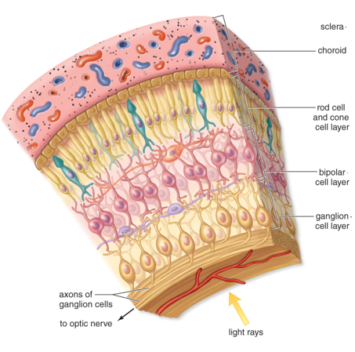
2) Light must hit the cones or rods to start a nerve signal
a) Up to 150 rods may activate 1 ganglion cell; one cone cell may stimulate 1 ganglion
b) Results in sharper image from cones
c) Center of receptive field stimulates ganglion to begin processing visual signals in eye

Blind Spot
1) No rods and cones exist in the optic nerve region
2) Results in a blind spot of vision

From Retina to the Visual Cortex
1) Optic nerves carry nerve signals from the eyes to the optic chiasma
2) Optic chiasma- X-shape formed from the crossing over of nerve fibers
a) Right visual field of each eye goes to the right occipital region
b) Left visual field of each eye goes to the left occipital region
3) Optic tracts go around the hypothalamus and synapse in the thalamus
4) Optic radiations from the thalamus innervate the primary visual area of the occipital lobe
5) Visual cortex – includes the primary and association vision centers
6) Communication between left and right hemisphere of the occipital lobe- rebuilds images
a) Allow for the complete picture to be integrated
b) Adjust image that is upside down and reversed
c) Stereoscopic vision- the impression of 3-dimensional width and depth
7) Visual association areas store visual memories

Corrective Lenses

1) Snellen chart- letters of different size on a chart used to determine visual acuity.
a) Numerator is the distance from the chart- always 20 feet.
b) Denominator is distance that a normal individual can read the letter
c) So if someone is 20/200 means what a normal person sees at 200 feet a person with
poor vision must be at 20 feet.
2) Myopia (nearsightedness) – people who see up close but not far away
a) Individuals have an elongate eyeball
b) Image rays focus in front of retina for distant objects
c) Must use concave / divergent lens- spreads the light rays out
d) Laser surgery- remove part of cornea to adjust for distance.
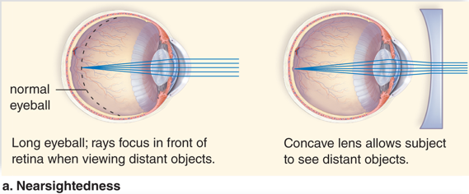

3) Hyperopia (farsightedness)- people who can see far but not up close
a) Individuals have a shortened eyeball
b) Image rays focus behind the retina for close objects
c) Must use convex / convergent lens – brings the light rays together
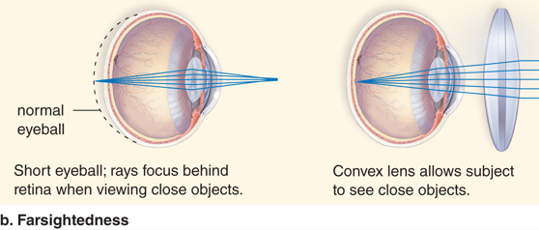

4) Astigmatism- when cornea assumes a oval instead of round shape.
a) Causes blurring of the image
b) Corrected using unevenly grounded lenses
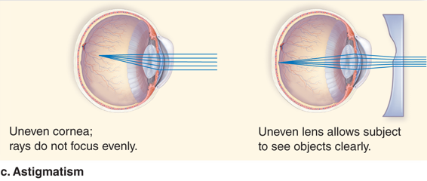

Eye Diseases and Disorders

1) Corneal damage caused by infection or injury can dim or distort vision
a) Corneal transplants from cadavers help to replace damaged ones
2) Cataract- lens of the eye becomes clouded making it harder to drive, read, and see details.
a) Risk factors- increase age, smoking, excessive sunlight exposure
b) Corrected by implanting a new artificial lens
3) Glaucoma- when the aqueous humor does not drain from the anterior chamber of the eye
a) Pressure in the eye can compress the retinal arteries. Can lead to partial or total
blindness
b) Usually treated with medicines first and then surgery if needed.
4) Macular degeneration (MD) – when retinal photoreceptors at the macula lutea are
damage; results in blurriness, blind spots, and color faded
a) Wet MD- abnormal blood vessels leak and destroy the macula
b) Dry MD- blood vessel growth does not occur – vision loss is less severe in dry
c) Risk factors- smoking, high blood pressure, light eye color, excessive sun exposure
d) Vitamins and new medicines may slow the process of dry MD. Laser treatment may
work for wet MD
5) Diabetic retinopathy- damage to the retina from poorly controlled diabetes mellitus.
a)Mild vision changes progresses to blurred and loss of vision
b) Laser treatment needed for when retina bleeds and detaches.

9.4 SENSE OF HEARING
Anatomy of the Ear
Three divisions to the ear- outer, middle and inner.
Outer Ear
1)Pinna- collects sound waves
2) Auditory Canal- filters air; directs sound waves to the tympanic membrane
a) Modified sweat glands secrete cerumen- waxy substance to guard against pollutants

Middle Ear
1)Tympanic membrane (ear drum) helps to amplify sound
2) Ossicles- tiny bones in middle ear responsible for amplifying sound
a) Malleus (hammer)
b) Incus (anvil)
c) Stapes (stirrup)
3) Tympanic membrane Malleus Incus Stapes oval window
4) Oval window- small membrane covered opening in the bone of inner ear
5) Round window- helps to diminish pressure waves in the inner ear
6) Auditory tube (Eustachian tube)- extends from middle ear to the nasopharynx equalizes air pressure

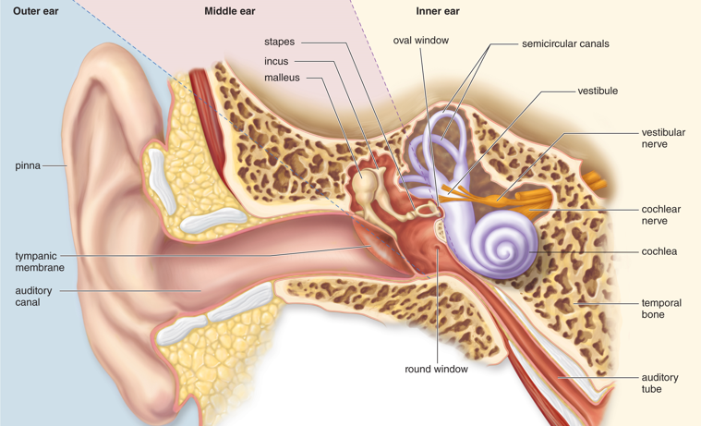

Inner Ear
1) Bony labyrinth- delicately carved cavity within the temporal bone of the skull.
2) Membranous labyrinth- tube of tissue inside the bony labyrinth
3) Perilymph- fluid similar to CSF between bony and membranous labyrinths
4) Endolymph- fluid that fills the membranous labyrinth
5) Three parts of the inner ear
a) Semicircular canals- rotational equilibrium – stereocilia embedded in cupula
b) Vestibule- gravitational equilibrium – stereocilia embedded in otolithic membrane
c) Cochlea- hearing – stereocilia embedded in tectorial membrane

Sound Pathway
Through the Auditory Canal and Middle Ear
1) Sound waves travel through the auditory canal
2) Vibrations from ear drum are amplified each time it passes from bone to bone of ossicles.
3) Stapes strikes the oval window and pressure wave is passed to the perilymph within the cochlea

From the Cochlea to the Auditory Cortex
1) Cochela has three ducts
a) Vestibular duct and tympanic ducts- are filled with perilymph
b) Cochlear duct- is filled with endolymph
i) Spiral organ – sense organ for hearing, consists of little hairs and a gelatinous
material
ii) Hair cells sit on the basilar membrane and the stereocilia are in the gelatinous
material (tectorial membrane)
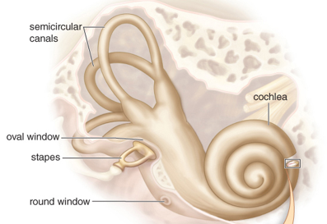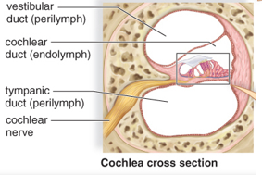

2) Stapes strikes oval window, then pressure waves travels through perilymph: vestibular duct tympanic duct across basilar membrane.
3) Basilar membrane moves up and down and stereocilia of the hair cells bend
4) Hair cells communicate with neurons of the cochlear nerve (VII- auditory nerve)
5) Bending the stereocilia of a hair cell causes changes in signaling, affects frequency of an action potential.
6) Signals are transmitted into the brain stem thalamus auditory cortex of temporal lobe.

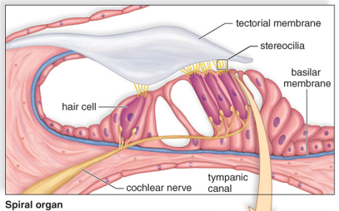
Spiral organ
1)Each part is sensitive to different wave frequencies or pitch
2)Near tip responds to low frequency and near base responds to high frequencies
3)Pitch sensation is determined by which region of the basilar membrane vibrates and what area of the auditory cortex is stimulated.
4) Volume is interpreted by the amplitude (height) of the sound wave from more pressure.
9.5 SENSE OF EQUILIBRIUM

Anatomy of equilibrium
1) Mechanoreceptors – a sense organ or cell that responds to mechanical stimuli
2)Semicircular canals detect rotational and/ or angular movement of the head (rotational, or dynamic equilibrium)
3) Vestibule detect head position as well as linear movement of the head in any direction (gravitational or static equilibrium)
4) Cerebellum- integrates information from inner ear
5) Proprioceptors in muscles and joints- sensory receptor that receives stimuli responding to position and movement.
6) Photoreceptors in the eye- help analyze movement

Rotational Equilibrium Pathway
1)Three semicircular canals with each one in a different dimension of space.
2) Tube of membranous labyrinth called a semicircular duct; each duct is filled with endolymph
3) Ampulla- enlarge base of the three ducts
4) Little hair cells, whose stereocilia are in a gelatinous material called cupula, are in the ampullae.
5) Each ampulla responds to movement in a different plane.
6) As cupula moves then stereocilia of hair cells bend, send signals carried by vestibular nerve
7) Cerebellum and brain centers use information to maintain balance via muscles
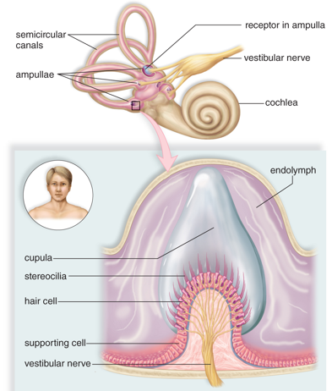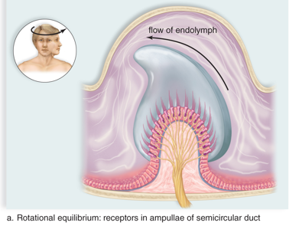
Abnormal rotational equilibrium
1) Vertigo- dizziness and a sense of rotation
a) can be caused by continuous movement of fluids in ducts
2) Seasickness- discrepancy between what feel and what see, if focus on horizon may help.

Gravitational Equilibrium Pathway
1) Depends on the utricle and saccule- endolymph- filled membranous sacs in the vestibule.
a) Utricle- is sensitive to horizontal (back-forth) motion
b) Saccule- is sensitive to vertical (up-down) movement
2) Both sacs contain stereocilia in a gelatinous material called an otolithic membrane
a) Otoliths- calcium carbonate granules rest on the membrane
3) When not moving- nerve signals cease as otoliths rest on membrane
4) When moving- otoliths are moved otolithic membrane sags; stereocilia bend
5) Move to or away from the largest stereocilia called a kinocilium – affects interpretation of
head movements
6) Cerebellum and brain centers respond to balance and keep us upright.

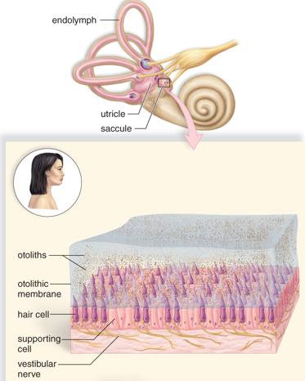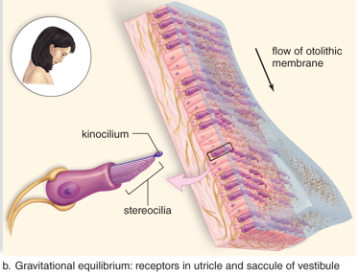

Hearing Damage and Deafness

1)Conduction deafness- mechanical blockage keeps soundwaves from reaching the oval window.
a) Caused by impacted wax, object, tumor, or repeated infection
b) Otosclerosis- normal bone of the middle ear is replaced by vascular, spongy bone
2) Nerve deafness- when cilia on the receptors within the cochlea have worn away
a) Age-associated hearing loss can be slowed or prevented by protecting ears from loud
noises
3) Aspects that lead to hearing loss
a) How loud the noise is – anything over 80 decibels
b) How long is the noise heard
c) How close is the noise to the ear

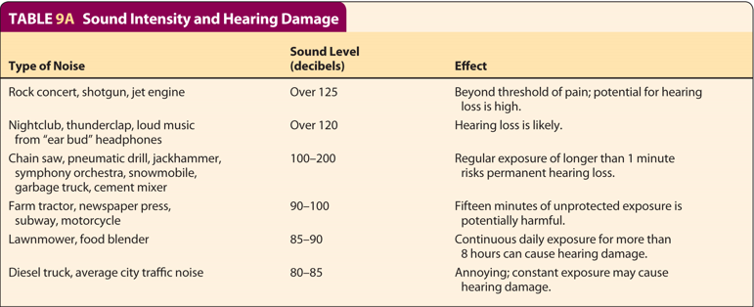

4)Early signs of hearing problems: temporary hearing loss, “full” feeling in the ears, muffled hearing or tinnitus – ringing in the ears
a) use ear plugs for occupational noise pollution
5) Medicines that are ototoxic- damaging to hearing or balance
a) Cancer drugs and antibiotics
6) Cochlear implants- directly stimulate the auditory nerve for sensorineural deafness

