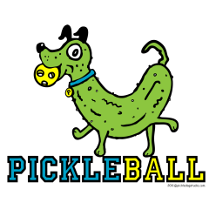
PICKLEBALL STUDY GUIDE
Below are the following terms, rules, critical elements, and tactical strategies that will be on the test.
SERVE
- Must be made behind the back baseline with at least ONE foot behind the line
- Contact with the ball can only be made below the waist
- You may not perform the serve off the bounce, must be in flight (similar to badminton)
- Serve may be replayed, if the ball hits the net and lands in the proper service court.

VOLLEY
- To volley a ball means to hit it in the air without first letting it bounce
- All volleying must be done with player's feet clearly behind the non-volley zone
- It is a fault if the player steps on or over the non-volley zone line during a volley.

DOUBLE-BOUNCE RULE
- Each team MUST PLAY its FIRST SHOT OFF THE BOUNCE.
- After the 2 bounces have occurred, the ball can be either be volleyed or played off the bounce

SCORING
- In our class, we play rally scoring, so you can score regardless of whether you are serving.

SKILLS COVERED IN CLASS

Forehand
Preparation Phase – Ready stance, eye on the ball
Execution Phase – Non-paddle side facing the net, parallel takeaway, parallel downswing with contact just at or in-front of the hip
Follow-through Phase – Paddle extends through towards intended target, finish across your body

Backhand
Preparation Phase – Ready stance, eye on the ball
Execution Phase – Paddle side facing the net, step across your body, parallel takeaway with a stiff wrist, parallel downswing with contact just in front of the hip
Follow-through Phase – Paddle extends through towards intended target, finish high to the sky

Drop shot or Dink
Preparation Phase – Ready stance with paddle in front of the body, eye on the ball
Execution Phase – Stay squared towards the net, extended paddle in direction of the ball (think of playing catch using the paddle as a mitt), NO TAKEAWAY, adjust paddle angle to change ball height
Follow-through Phase – make contact in front of the body, NO FOLLOW-THROUGH

Smash
Preparation Phase – Attack the net, ready stance
Execution Phase – Non-paddle side facing the net, paddle to hip, eye on the ball, body under the ball, reach high to strike ball at high point, paddle angled downward
Follow-through Phase – Pull downward across your body, return to ready stance
STRATEGIES
- Serves should go deep into the opponents court to push opponent away from the net
- Use a dink or smash when opponents are deep in their court to ‘win the point’

HOW TO CORRECT SKILL EXECUTION
During a forehand or backhand…
- Miss to the right or left – TIMING of SWING
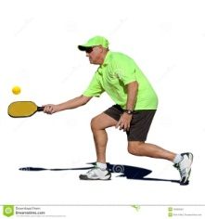
- Miss too high or too low – ANGLE OF THE PADDLE
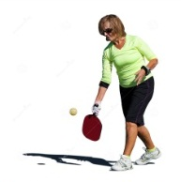
Serve - Forehand -

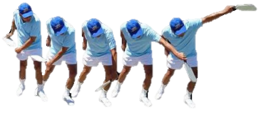
Backhand -

TEST DATES - Mon/Weds on 2/1 & Tues/Thurs on 2/2

